ASSIGNMENT :

Module – 1 Understanding of Hardware and Its Components.

Section 1 : Multiple Choice

1. Which of the following is NOT a component of CPU ?
2. ALU
3. RAM
4. CU
5. 1 and 3 both

Correct Answer is : 2 : RAM

1. What is the function of RAM in a computer ?

Answer : RAM ( Random Access Memory ) is a type of computer memory that plays a crucial role in the performance and operation of a computer. Its main functions are :

1 . Temporary Data Storage : RAM temporarily stores data that the CPU ( Central Processing Unit ) needs while performing tasks.

2.Fast Access : Ram is much faster than other types of storage like hard drives (HDDs) or even solid -state drives (SSDs).

3.Multitasking Support : When you run multiple programs at once, each one uses a part of RAM and the more tasks it can handle simultaneously without slowing down.

4.Running Programs : Applications and the operating system are loaded from the hard drive into RAM so they can run or by not using sufficient RAM, your system may become slow or unable to run certain software.

3. Which of the following is a primary storage device?

1. HDD

2. SSD

3. SD card

4. 1 and 2 both

Correct Answer is : Above given options are not applicable for correct option as per the question.

4. What is the purpose of a GPU?

Answer : A GPU ( Graphics Processing Unit ) is a specialized processor designed to accelerate the creation and rendering of images, videos, and animations. It performs rapid mathematical calculations, primarily for tasks involving graphics and visual output.

Main purposes of a GPU:

1. Graphics Rendering : The primary role of a GPU is to render graphics for display on a monitor and its includes 2D and 3D images in games, user interfaces, and visual applications.
2. Offloading Tasks from CPU : GPUS handle complex calculations, especially those parallel processing, freeing up the CPU for other tasks.
3. Gaming and Multimedia : Essential for high-performance gaming , video playback , and media editing. They provide smooth graphics, higher frame rates, and better visual effects.
4. Hardware Acceleration : GPUS seed up specific processes like video encoding/decoding, image processing, and rendering by offloading them from the CPU.

Scientific Computing and AI : Modern GPUs are used in machine learning, deep learning, and data science due to their ability to perform massive parallel computations efficiently.

Section 2 : True or False

5. The motherboard is the main circuit board of a computer where other components are attached.

Answer : True

6. A UPS (Uninterruptible Power Supply) is a hardware device that provides emergency power to a load when the input power source fails.

Answer : True

7. An expansion card is a circuit board that enhances the functionality of a component.

Answer : True

Section 3 : Short Answer

8 . Explain the difference between HDD and SSD .

Answer : In HDD , it uses spinning magnetic disks to store data in storage.

It is cheaper in prize bigger in storage and slower in speed.

In SSD , it uses flash memory chips for no moving parts.

It is faster in speed or quitter and more durable but costs is more for the same storage size.

9 . Describe the function of BIOS in a computer system.

Answer : Functions of the BIOS in computer are

* Performs post checks hardware components like CPU,RAM, and storage to ensure they are working properly before the operating system.
* Loads the Bootloaders finds and starts the operating system from the hard drive, SSD, or other bootable devices .

10. List and briefly explain three input devices commonly used with computers.

Answer : Here are the three common input devices and their functions are keyboard, mouse and scanner .

Section 4 : Practical Applications

11. Identify and label the following components on a diagram of a motherboard:

● CPU

● RAM slots

● SATA connectors

● PCI-E slot

Answer :

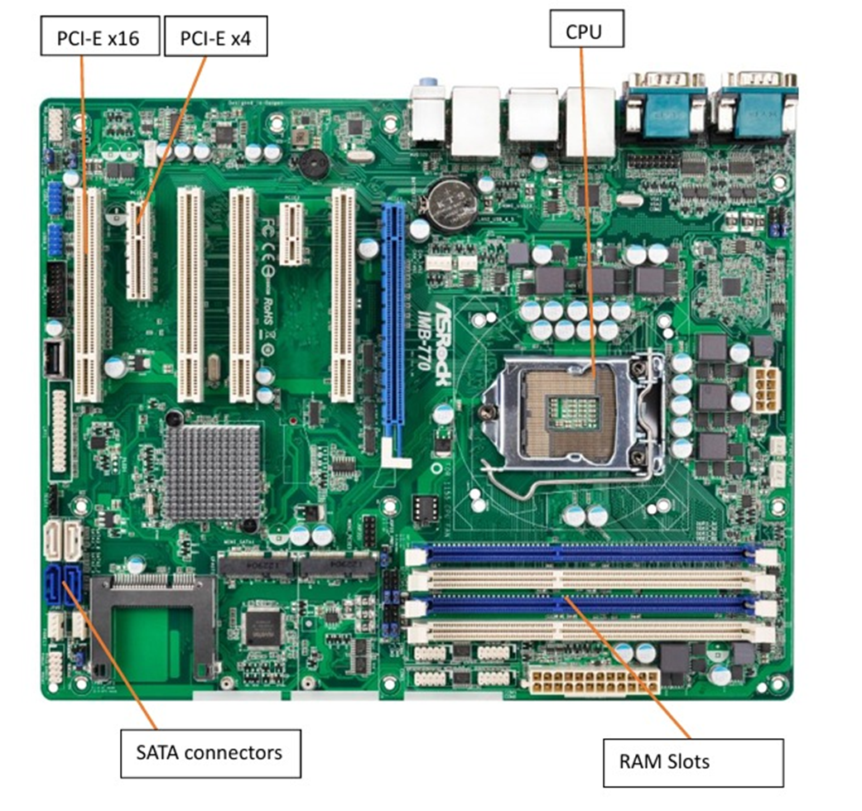

12. Demonstrate how to install a RAM module into a computer.

Answer : Step 1 – Open the Computer Case

1. Lay the computer on its side so the motherboard is facing up when you open it.
2. Remove screws or press release latches on the side panel.
3. Slide off or open the side panel.

Step 2 – Loate the Ram Slots

1. Look for long slots next to the CPU socket.
2. Usually, there are two to four slots, often labeled DIMM1, DIMM2, etc. and color-coded.

Step 3 – Prepare the Slot

1. If a slot is occupied and you want to replace the RAM, push down the two retaining clips on each end to release the old module.
2. For an empty slot, Just make sure the clips are open.

Step 4 – Align the RAmModule

1. RAM has a small notch along its gold contacts – it must match the key in the slot.
2. Hold the RAM by the edges, never touch the gold contacts.

Step – 5 Insert the RAM

1. Align the notch with the slot key.
2. Press the module firmly and evenly down both retaining clips snap into place.

You may need to apply more pressure than you expect – but do not force it if the notch doesn’t match.

Step 6 – Close the Case

1. Put the side panel back on.
2. Secure it with screws or clips.

Step 7 – Test the installation

1. Plug in the computer and power it on.
2. Enter BIOS/UEFI ( usually by pressing Del or F2 at startup ) to confirm the system recognizes the new RAM.

Alternatively, in Windows, press Ctrl + Shift + Esc – Performance tab – Memory to check total RAM.

Section 5 : Essay

13. Discuss the importance of proper cooling mechanisms in a computer system. Include examples of cooling methods and their effectiveness.

Answer : Proper cooling in a computer system is crucial because electronic components—especially the CPU, GPU, and power supply—generate heat during operation. If this heat is not effectively removed, it can lead to: Reduced performance (thermal throttling), Shortened component lifespan due to prolonged high temperatures, System instability or crashes, Potential permanent hardware damage

Proper Cooling Matters : Maintains Performance – Modern processors automatically slow down when they overheat, which prevents damage but also reduces speed.

Prevents Hardware Failure – Heat accelerates wear on circuits, capacitors, and solder joints.

Ensures System Stability – Overheating can cause sudden restarts, freezes, or graphical glitches.

Supports Overclocking – Higher performance settings require more heat dissipation.

Common Cooling Methods and Effectiveness

1 . Air Cooling : Uses fans and heat sinks to move heat away from components into the surrounding air.

Examples: Stock CPU coolers, aftermarket tower coolers, case fans.

Effectiveness:

Pros: Cost-effective, easy to install, reliable.

Cons: Limited cooling for extreme workloads; dependent on airflow and ambient temperature.

Use Case: Everyday computing, gaming PCs with moderate heat output.

2. Liquid Cooling (Water Cooling) : Uses liquid coolant to transfer heat from components to a radiator, where fans dissipate it.

Examples: All-in-One (AIO) liquid coolers, custom water loops.

Effectiveness:

Pros: Superior heat transfer, quieter operation, supports high-performance overclocking.

Cons: More expensive, risk of leaks, requires more maintenance.

Use Case: High-end gaming PCs, workstations, overclocked systems.

3. Thermal Interface Materials (TIM) : Thermal paste or pads placed between the CPU/GPU and heat sink to improve heat transfer.

Effectiveness:

Pros: Essential for maximizing heat sink efficiency.

Cons: Needs periodic replacement as it dries out.

Use Case: All systems (mandatory for effective cooling).

4. Passive Cooling : Relies on heat sinks and natural convection without fans.

Effectiveness:

Pros: Silent, no moving parts to fail.

Cons: Limited cooling capacity; only suitable for low-power devices.

Use Case: Laptops, embedded systems, fanless mini PCs.

5. Specialized Cooling : Examples:

Phase Change Cooling – Works like a refrigerator; for extreme overclocking.

Liquid Metal Cooling – Uses conductive liquid metal as TIM for maximum heat transfer.

Immersion Cooling – Components submerged in non-conductive liquid; used in data centers.

Conclusion : Proper cooling is not just about preventing overheating—it’s about enabling a computer to run at peak performance, remain stable, and have a long operational life. The choice of cooling method depends on system usage, performance needs, budget, and environmental conditions.

For most users, a well-ventilated case with quality air cooling is sufficient, but for heavy workloads or overclocking, liquid cooling or advanced methods may be necessary.

If you want, I can prepare a comparison table showing each cooling method’s cost, complexity, noise level, and performance so it’s easier to evaluate.

14. Explain the concept of bus width and its significance in computer architecture.

Answer : Bus Width in Computer Architecture – Explanation

A bus in computer architecture is a set of parallel wires or traces that carry data, addresses, and control signals between different components of a computer (like the CPU, memory, and I/O devices).

Bus width refers to the number of bits that can be transmitted simultaneously over the bus.

For example, a 32-bit bus can carry 32 bits (4 bytes) of data in one operation, while a 64-bit bus can carry 64 bits (8 bytes) at once.

Types of Buses

1. Data Bus – carries actual data between components. Its width directly determines how many bits of data can be transferred at once.

2. Address Bus – carries memory or I/O addresses. Its width determines the maximum addressable memory space.

3. Control Bus – carries control signals (read/write, clock, etc.). Width here refers to the number of control lines.

Significance of Bus Width

1. Data Transfer Speed : Wider buses can transfer more bits in one cycle, improving overall system throughput. Example:

32-bit data bus @ 100 MHz → transfers 4 bytes × 100M = 400 MB/s

64-bit data bus @ 100 MHz → transfers 8 bytes × 100M = 800 MB/s

2. Memory Addressing Capability : The width of the address bus determines how much memory the CPU can directly address.

n-bit address bus → addressable locations.

32-bit address bus → addresses → 4 GB memory limit.

3. Processor Architecture Compatibility : 32-bit CPUs typically have 32-bit data and address buses, while 64-bit CPUs have 64-bit data buses and can address much more memory.

4. System Cost and Complexity : Wider buses require more physical lines on the motherboard, which can increase manufacturing cost and complexity.

Quick Analogy : Think of the bus as a highway, and the bus width as the number of lanes.

More lanes → more cars (data) can travel at once → faster transport.

But more lanes also mean more construction cost and design complexity.

If you want, I can also give you a diagram showing how bus width affects data flow in a CPU–memory system so it’s easier to visualize.